|  |
| --- |
|  |
| **AUGUST 2025 Newsletter**  **Volume XIV issue VIII** |
|  |

**Sons of Norway**

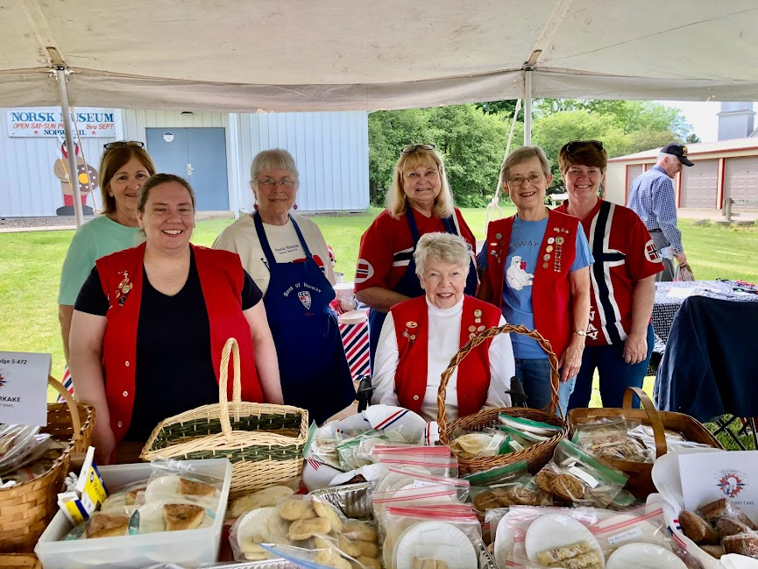

**Coming Soon….Norwegian Bakeri at Scandinavian Days at Vasa Park and at the Heritage Weekend In Norway, Il.**

**UPCOMING EVENTS**

# Scandinavian Days

**at**

**Vasa Park**

**Sunday September 7th**

**see details on Page 2**

**\*\*\*\*\*\*\*\*\*\*\*\*\*\*\*\*\*\*\*\*\*\*\*\*\*\*\*\*\*\*\***

**District 5**

**Heritage Weekend**

**October 3-5, 2025**

**Norway Community**

**Building**

**Norway, Illinois**

**details on page 3**

**Polar Star Newsletter Deadline**

**Will be the 14th of every month. Please submit all articles to Barb Johnson at** [**barbjjohnsonb@aol.com**](mailto:barbjjohnsonb@aol.com)

**Follow us on facebook @**

**Sons of Norway – Polar Star Lodge**

**Polar Star Lodge 5-472**

**Meetings on the first Sunday of the month – Potluck at 1:30 p.m.**

**St. Olaf Lutheran Church – Douglas Road, Montgomery, Il**

**President’s Message**

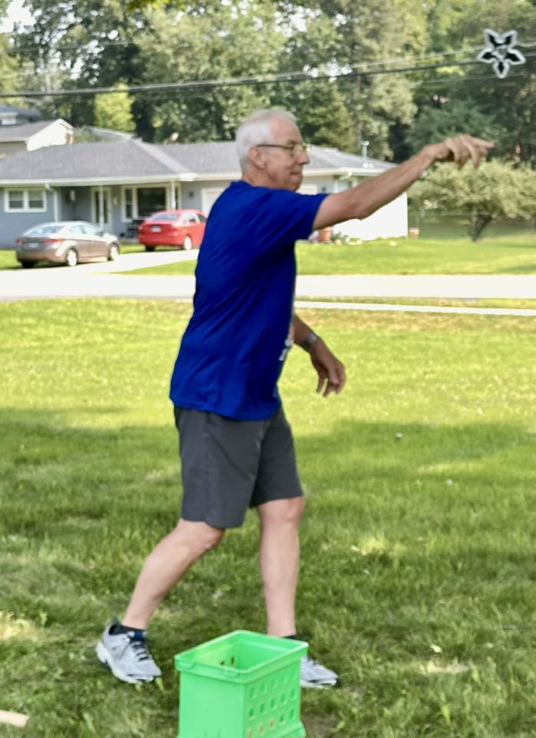

**President Ken competing in Polar Star Lodge Team Toss**

**Polar Star has a full fall Schedule and we need all hands on deck! Please send in your registration to participate in “Celebrating Norwegian Immigration” . Take a look at the complete schedule and let Karen Oswald know how you will help make the weekend successful. If you are a baker we need your skills at Scandinavian Day at Vasa Park for our Polar Star Bakeri and again for Coffee breaks and the Slooper luncheon for the Heritage Weekend. Please let Nancy Andersen know what you will be brining to both events.**

**Thanks in advance for your time and commitment to our Lodge activities this fall. Looking forward to seeing all of you!**

**Your President**

**Ken**

**Polar Star members walk the**

**POLAR STAR PIONEER PIKNIC 2025**

|  |
| --- |
|  |
| **Welcome to Polar Star Paul !** |
|  |
|  |

**Polar Star members learn how to make lefse at the January 4th workshop under the direction of Vi Skogen .**

**Vasa Park Scandinavian Festival**

**Sunday, September 7, 2025**

**10:00 – 5:30**

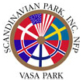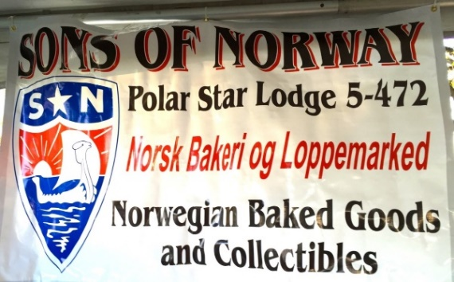

**The Polar Star “Norsk Bakeri and Loppemarked” will showcase our Norwegian heritage at the 45th annual festival of Scandinavian heritage at Vasa Park in South Elgin on Sunday, September 7, 2025. Our booth will feature our homemade traditional baked goods and our “on site “Norwegian Vafler. President Ken has also collected a wide variety of Norwegian “flea market” items that will be sold. Set up will begin at 8:00 a.m and we will work our booth until our baked goods are sold or the last act has performed on the main stage. Please contact Nancy to let her know what baked goods you will be bringing or if you are willing to work in the booth. Call Barb or Kenny if you need to have your baked goods picked up.**

**Bring a lawn chair and plan to enjoy a beautiful day immersed in Scandinavian culture.**

**This event is our main fund raising event for the year and replaces our September Lodge Meeting.**

**We will not be meeting at St. Olaf on Sept. 1st.**

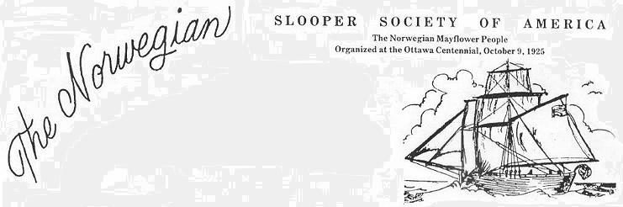

**POLAR STAR**

**OCTOBER LODGE EVENT**

**will be held at the**

**Slooper Society**

**Annual Meeting**

**Norway Community Building**

**October 5, 2025 at Noon.**

**Polar Star Lodge will hold our October Lodge Meeting at the Norway Community Building on October 5th, 2025 to Celebrate the 200th anniversary of Norwegian Immigration to the Fox Valley area of Illinois . This year, the annual gathering of the descendants of the “Restauration”, who call themselves “Sloopers” will culminate a weekend of District 5 Heritage activities at the Norwary Community Building. The weekend is sponsored by Polar Star Lodge, Cleng Peerson Lodge, The Slooper Society of American, the Norsk Museum and the village of Norway, Illinois. This event gives our lodge and the Norwegian community an opportunity to meet with other groups who are connected to the ship that brought the first permanent Norwegian settlers to the Illinois prairie. There will be a catered lunch for $20.00 that must be prepaid. Please RSVP using the attached Heritage Weekend registration form by September 1st. (A full schedule of events can be found on the Polar Star Website.**

**Please plan to bring Norwegian baked goods to share with the Heritage Weekend visitors.**

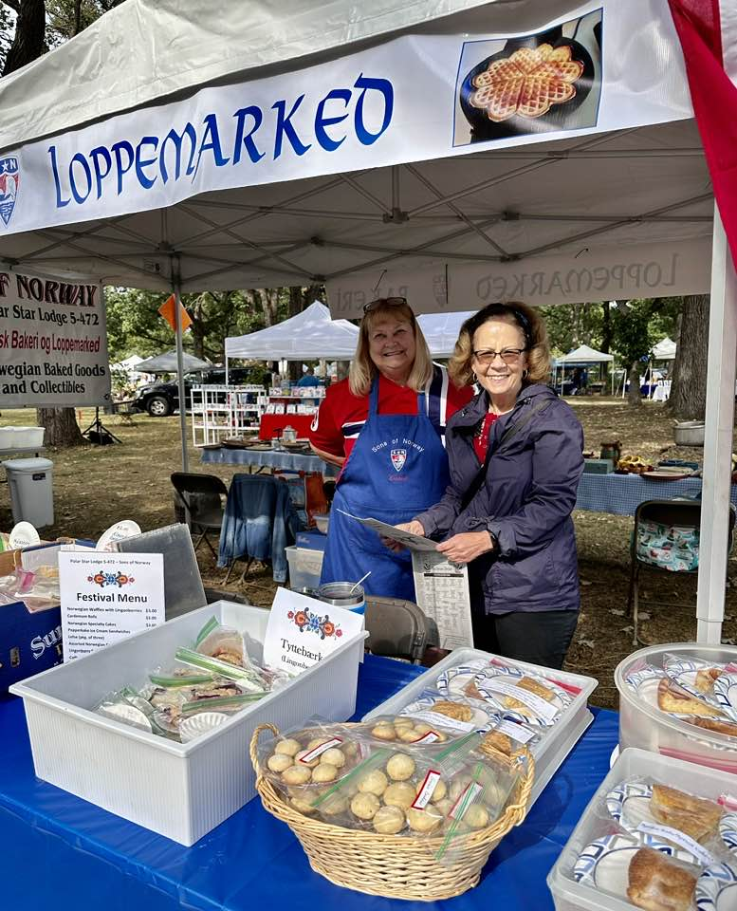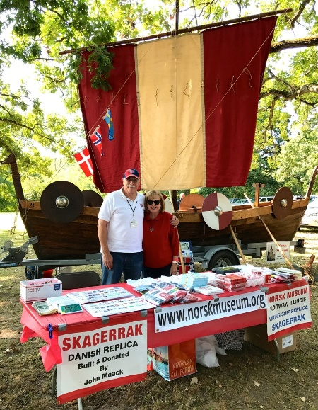



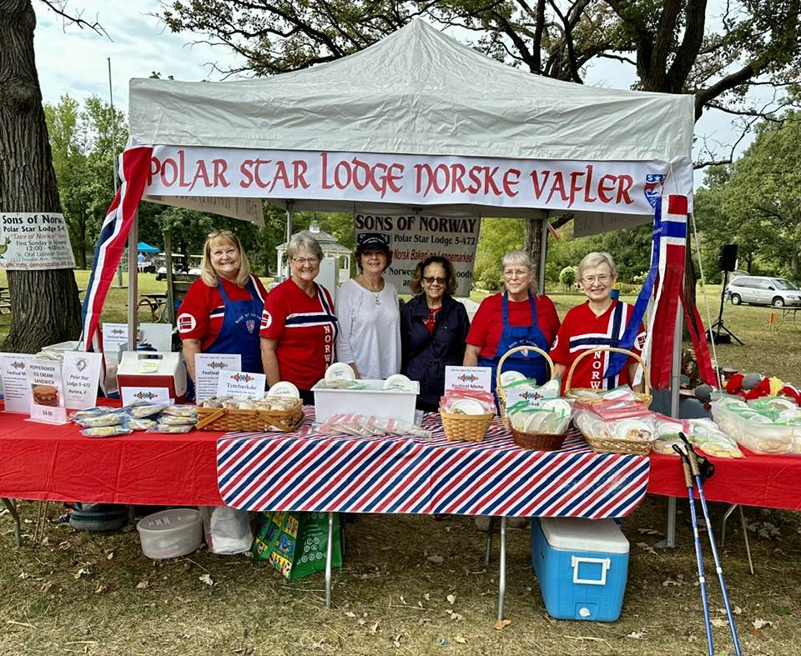

See you at the Polar Star Lodge Bakeri on September 7th!

at Vasa Park in South Elgin

**Set up begins at 8:00 a.m.**

**POLAR STAR CULTURAL CORNER**

**by**

**Barb Johnson**

**Sons of Norway Book Club**

**September Book Selections**

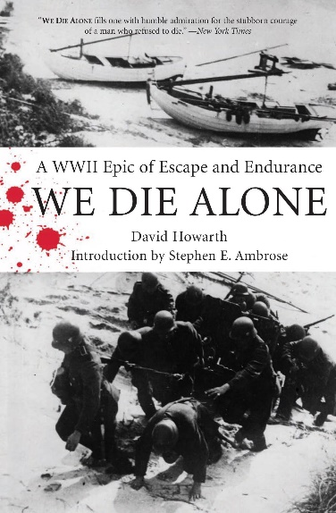 

**Main Read: “*We Did Alone”* by David Howarth**

**Mystery Read: *“Still”* (Sandhamn Murders Book 1 by Viveca Sten**

**To join the Sons of Norway Book Club, please send an email to: Bill Browning SonsofNorwayBookClub@gmail.com**

**\*\*\*\*\*\*\*\*\*\*\*\*\*\*\*\*\*\*\*\*\*\*\*\*\*\*\*\*\*\*\*\*\*\*\*\*\*\*\*\*\*\*\*\*\*\*\*\*\*\*\*\*\*\*\*\*\*\*\*\*\*\*\*\*\*\*\*\*\*\*\*\*\*\*\*\*\*\*\*\*\*\*\*\*\*\*\*\*\*\*\*\*\*\*\*\*\*\*\*\***

**Polar Star Sports and Activities**

**by Jerri Lynn Baker**

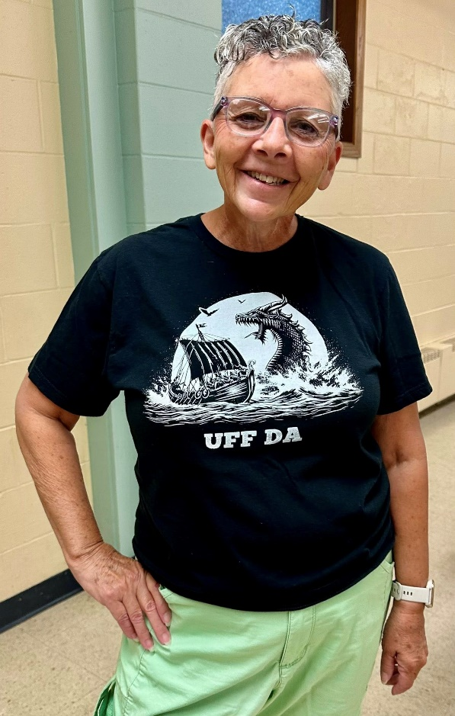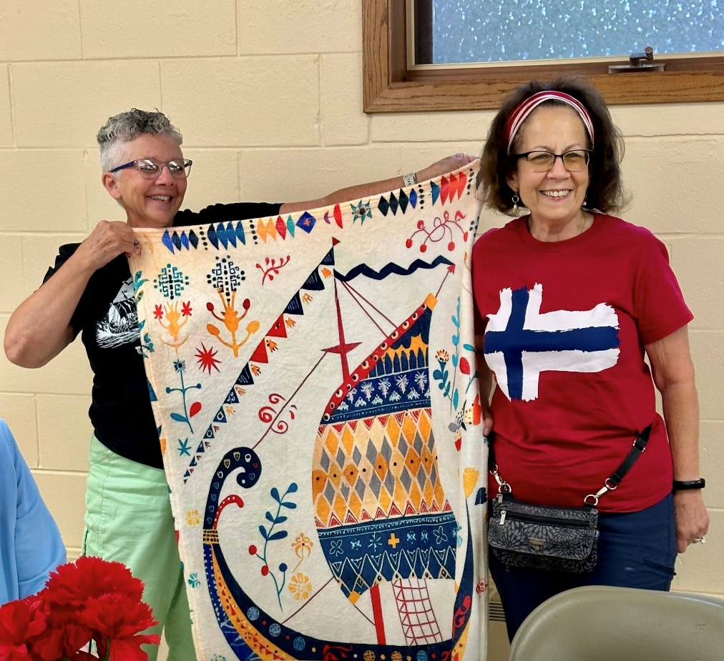

**Just a reminder Polar Star Virtual Walkers….”Celebration Migration”**

**WE HAVE ALMOST THERE!!!**

**On August 4th, 2024 the Polar Star Virtual Walkers began the 836 mile trip from New York to Norway, Illinois. "Celebration Migration" has been our theme. October 9th, 2025 marks the 200th anniversary of the “Sloopers” arriving in America but we will celebrate the end of our walk on Saturday morning October 4th as we complete our “Sluppen Around Norway” Fun Walk..**

**Congratulations to Diana Raimond who has already arrived and will be waiting for us at the starting line of the Fun Walk!!**

**GRATULERER MED DAGEN POLAR STAR**


marzipan cake-2 

**16 - 31 AUGUST 1-14 SEPTEMBER**

**20 August - Floyd Anderson 2 September - Frances Berg**

**23 August - Penny Ray 4 September – Gardis Dale**

**30 August - Cynthia Ann Olson**

**\*\*\*\*\*\*\*\*\*\*\*\*\*\*\*\*\*\*\*\*\*\*\*\*\*\*\*\*\*\*\*\*\*\*\*\*\*\*\*\*\*\*\*\*\*\*\*\*\*\*\*\*\*\*\*\***

**POLAR STAR CALENDAR OF EVENTS**

**All events held at St. Olaf Lutheran Church, Montgomery, Il at 1:30 unless otherwise listed**

**SEPTEMBER 7 - VASA PARK 9:00**

**Scandinavian Festival**

**OCTOBER 3-5 – Celebration Norwegian Immigration Heritage Weekend**

**Norway, Illinois**

**October 5 -Slooper Society of America Annual Meeting**

**Noon Lunch and Program at Norway Community Buidling**

**NOVEMBER 2 - Høstfest begins at 11:30 a.m.**

**DECEMBER 1 - JULETREFEST**

**Polar Star Pioneer Piknik and Games 2025**

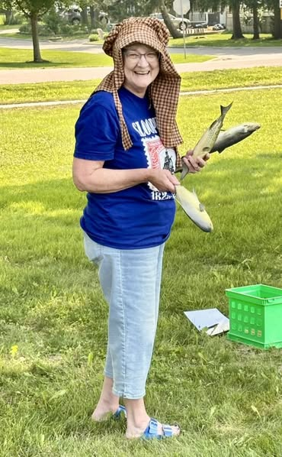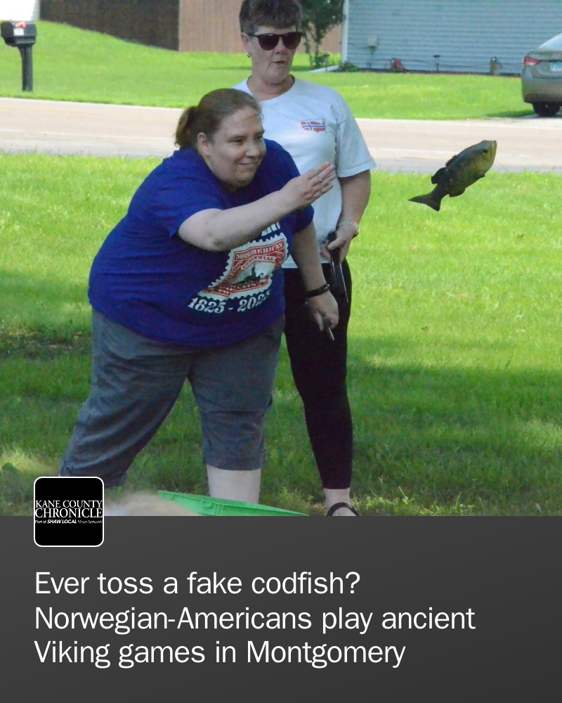

**Polar Star Lodge “Throws in” for the**

**District 5 Lodge Competition 2025**

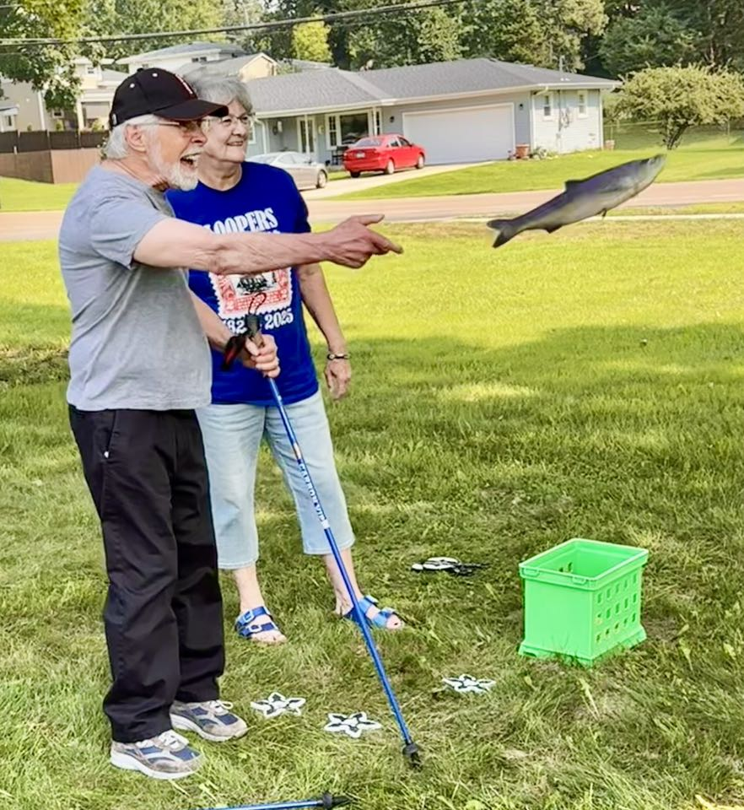 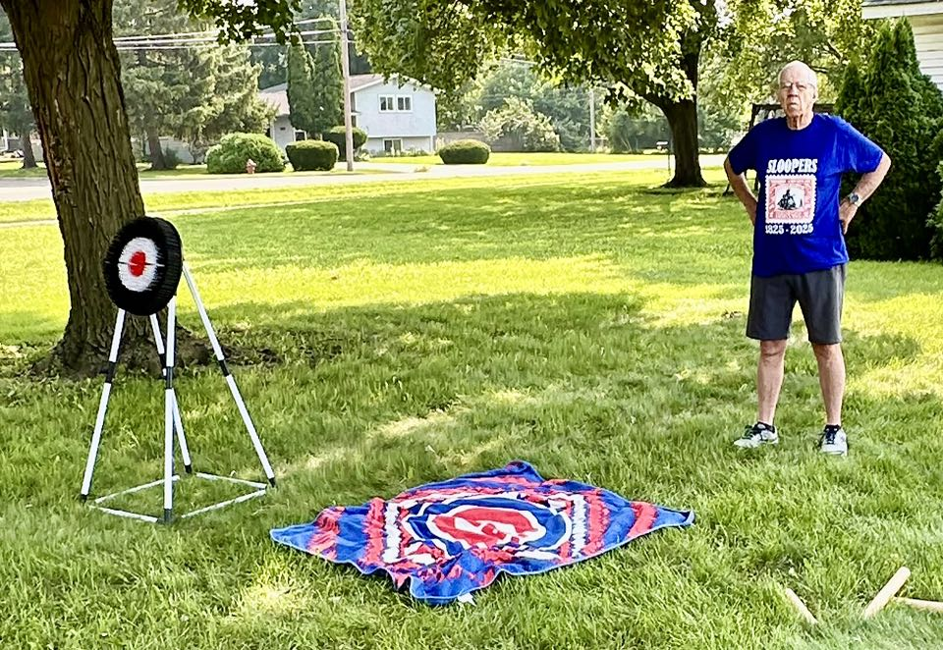

**TORSK TOSS**

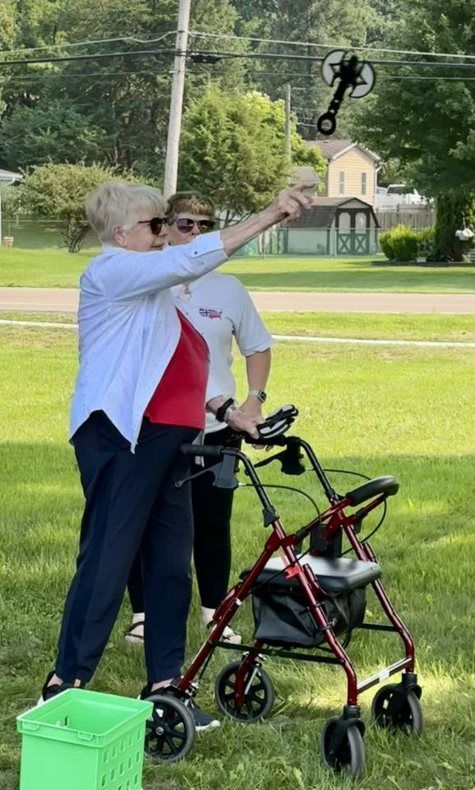 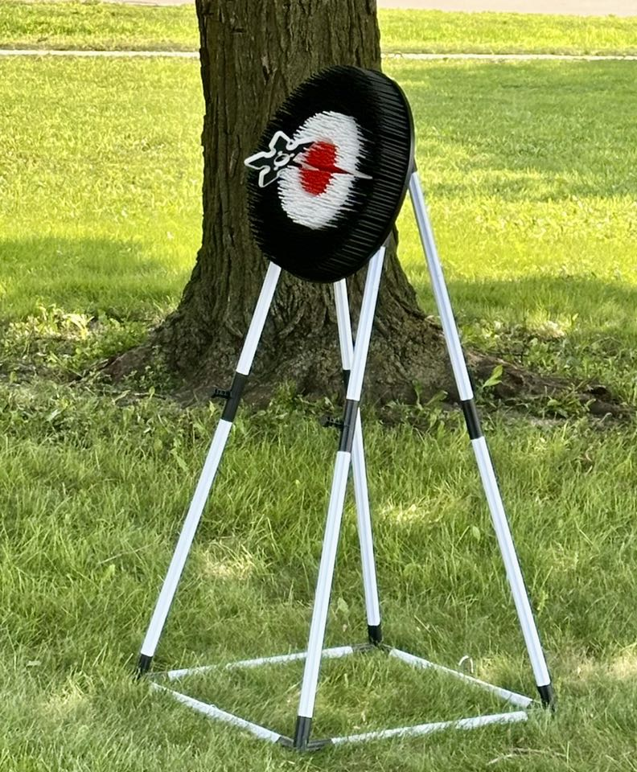

**BATTLE AX THROWING**

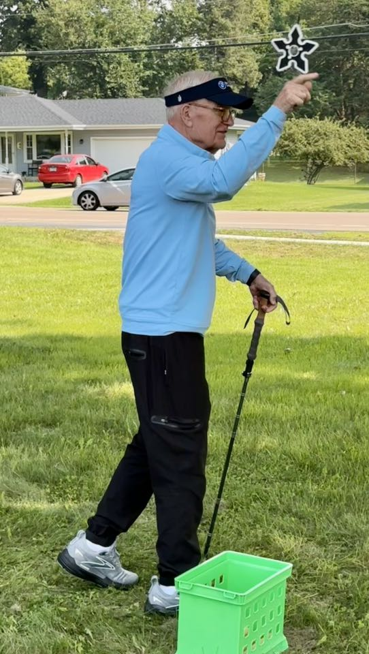

**THROWING STARS**

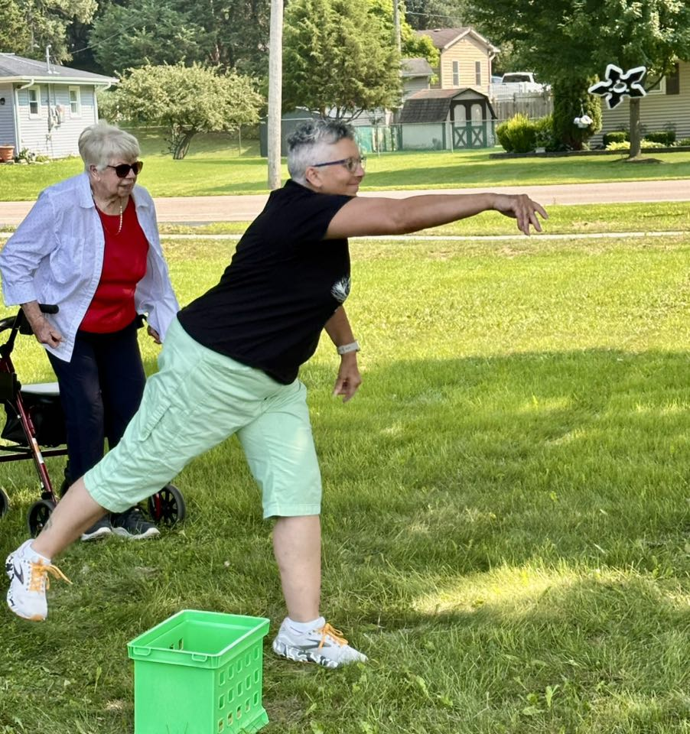

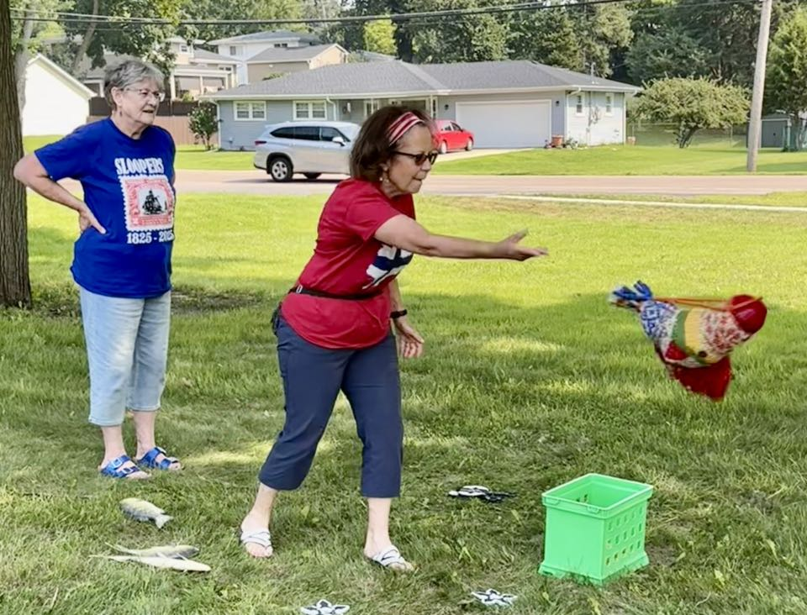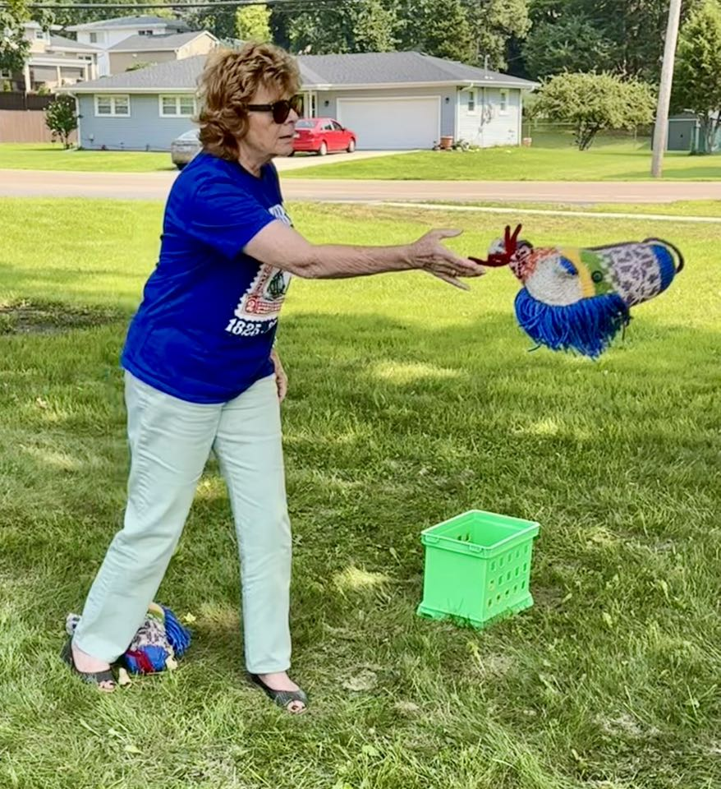

**FJORD HORSE HEAD THROW**

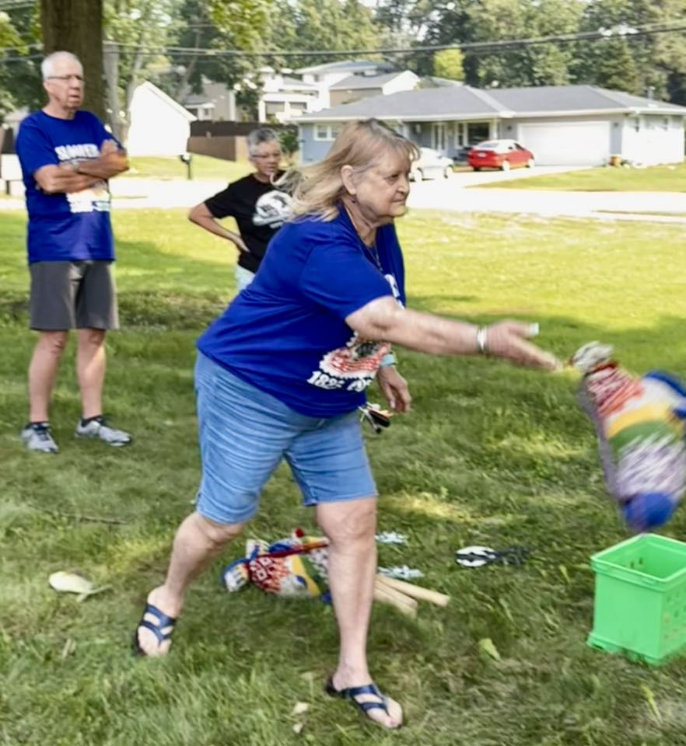

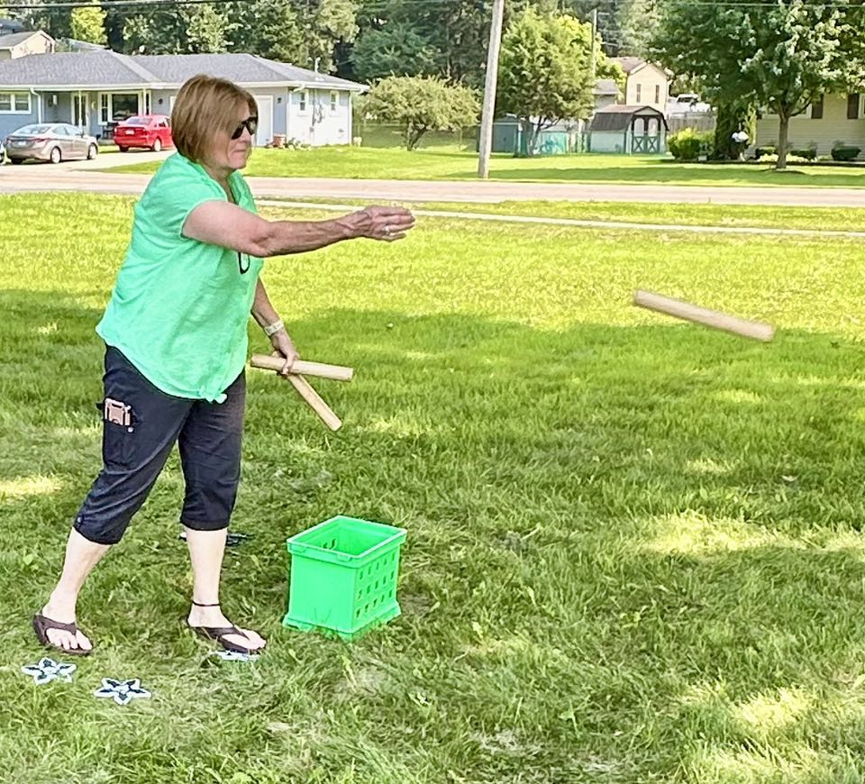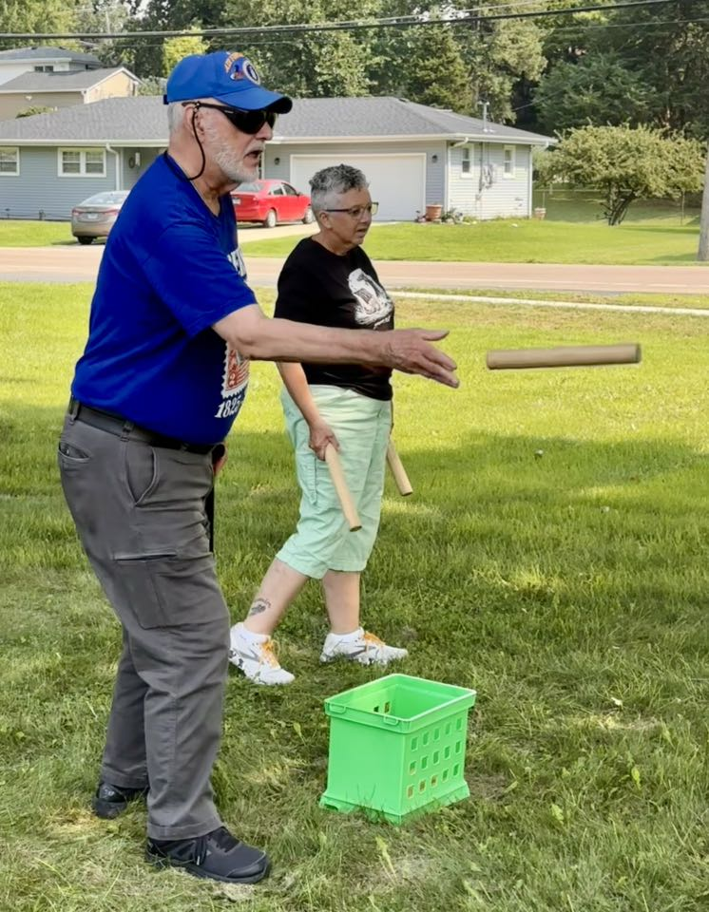

**KUBB THROW**

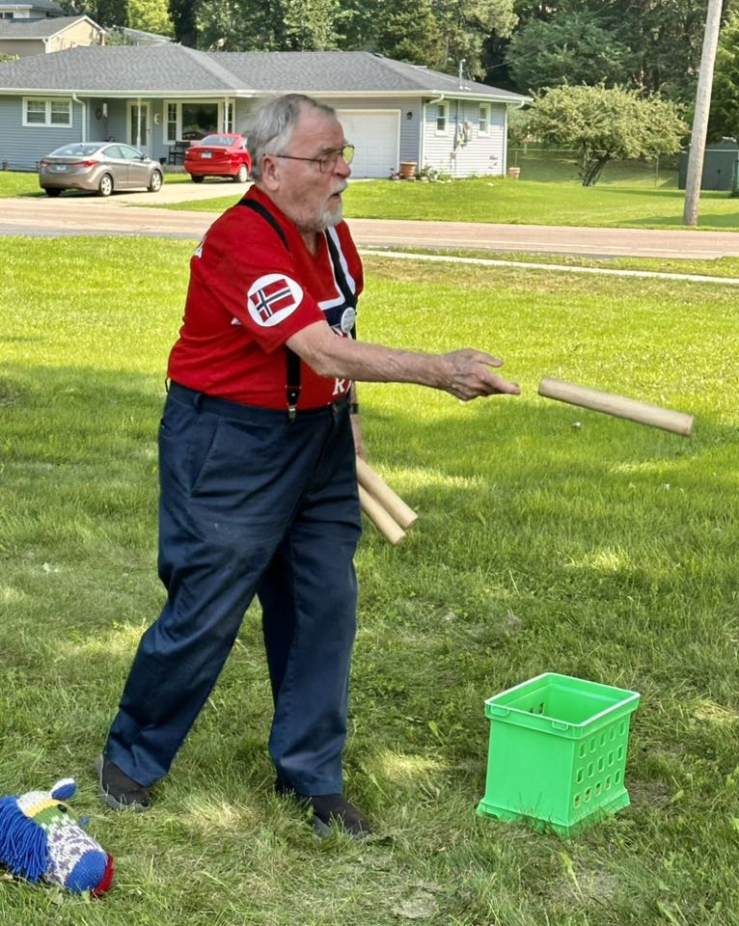

**2025 PIONEER PIKNIC “TEAM TOSS” GOLD MEDAL WINNING TEAM**

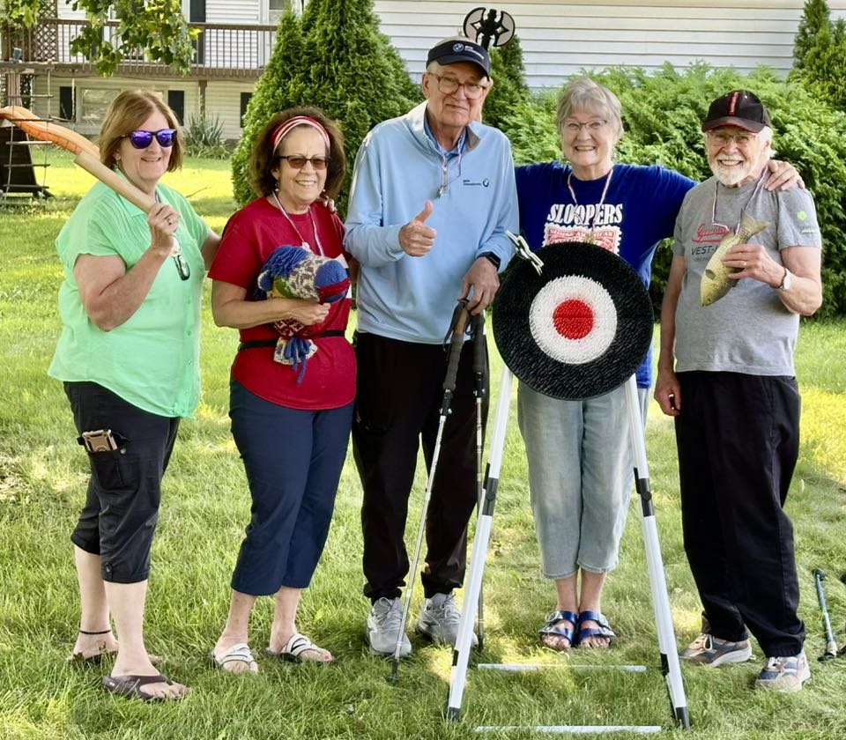

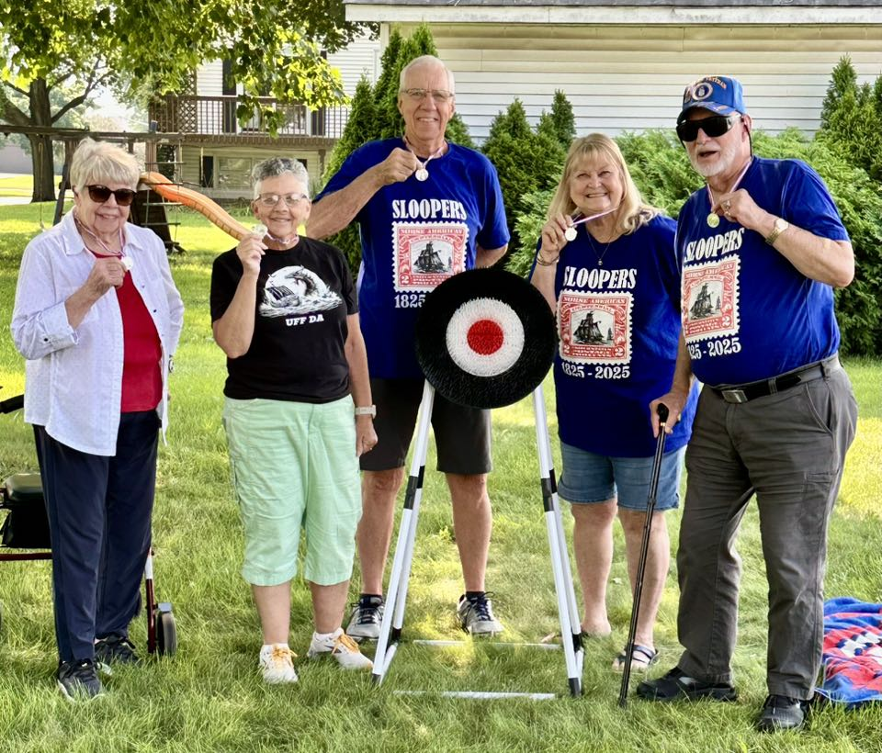

**SILVER MEDAL TEAM**

**Congratulations to all!!**

**Sons of Norway  
Polar Star Lodge 5-472  
Regular Meeting, August 3, 2025**

**St. Olaf Lutheran Church  
1233 Douglas Avenue  
Montgomery, IL 60538**

President Johnson called the meeting to order following a 1:30 p.m. Pioneer Polse Piknik luncheon.

**President Announcements:**

* Ken opened the meeting with the Pledge of Allegiance, and welcomed everyone.
* Paul Thomason was introduced. He recently visited Norway, and has just joined our Polar Star Lodge.
* There were no objections to the April meeting minutes.

**Treasurer Report:** Carol read a summary of the monthly Treasurer’s report (copy attached). Current checking account balance is $13,490.36, and our total assets $28,102.47. Motion to approve the report was made, seconded, and passed.

**Sports Director Report:**

* Jerri Lynn reported that 53 people have signed up for the October 4th Slooper Fun Walk.
* She talked about our August 4, 2024 to Oct 5, 2025 immigration virtual walk from New York City to Norway, IL, and reminded everyone to keep walking.
* Diana Raimond completed the 836 mile walk. She was awarded a pin for being the first finisher, and was given a very nice, soft blanket. Diana agreed that all of her mileage for the remaining months of our virtual walk will go to Floyd Anderson, who has been in and out of Edward Hospital and Marianjoy Rehabilitation Center over these last months.
* Everyone agreed that each walkers’ surplus miles will go to Floyd.

**Social Director Report:**

* We need to begin baking for our 4 big upcoming events:
  + Oct 3-4-5 - Cultural Weekend Event
  + September 7 - Vasa Park
  + November 2 - Hostfest
  + December 7 - Christmas Julefest
* Nancy stressed that our October Cultural Weekend Event is a very important historical event, celebrating the 200th anniversary of the very first *organized* Norwegian immigration: the 1825 immigration of the “Sloopers”.
* For the Oct 3-4-5 - Cultural Weekend, we need to bake goods that won’t spoil (for example, cookies and bars). Nancy plans to make simple cakes (without whipped cream, etc.)
* The Norwegian American newspaper had 18 photos; 4 of those photos were from us. They also published Dave Johnson’s Oslo Syttende Mai Parade picture.

**Cultural Director Report:**

* So far, 81 people have signed up for our Cultural Heritage Weekend event.
* Barb announced that while she and Ken were in Stavanger, Norway in July, President Ken actually stood on the deck of the Restauration sloop replica, standing by haddock drying on a traditional rack. She also said that Jeanne and Craig Leifheit will be in New York City to see the Restauration arrive.
* Wow – between seeing the Restauration launched in Stavanger Norway, seeing it arrive in New York after its long voyage across the Atlantic Ocean, and planning and hosting our October Cultural Heritage Weekend celebration, our Polar Star lodge is well represented in this important historical event celebration!

**Meeting Adjournment:** After adjournment, we all went outside. To participate in the 2025 District 5 Lodge Throwing Competition. Barb Johnson developed a throwing game called “Pioneer Picnic Team Tossing”. There were three teams, 5 people per team, and five different things to toss: rubber “cod” fish, Kubb batons, axes, stars, and fjord horse heads. Two rounds were played, and the team with the most points earned gold medals. Fun was had by all. The weather was terrific!

**Next Meeting/Event:** Sunday, September 7, the annual Vasa Park Scandinavian Festival

Respectfully submitted,  
Karen Oswald, Secretary  
Diana Raimond, Assistant Secretary

Sons of Norway - Polar Star Lodge 5-472

**[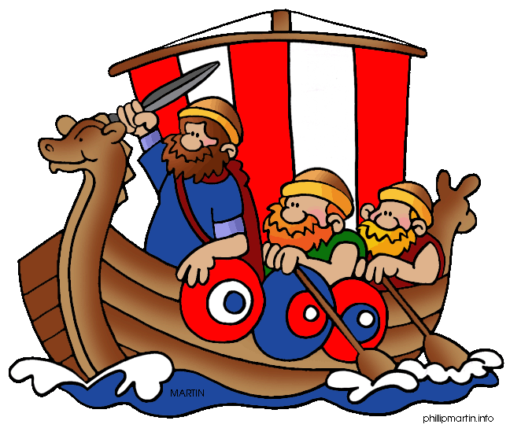](http://www.wartgames.com/themes/worldhistory.html)**

“Taste **of Norway”**

**Høstfest – Fall Festival**

**Sunday, November 2, 2025**

St. Olaf Lutheran Church – 1233 Douglas Ave.

Noon - 3:30 p.m.

Montgomery, Il

Taste Traditional Norwegian Food

Shop for Scandinavian gifts

Lefse and Krumkake demonstrations

Norwegian Craft demonstrations

**Contact: Polar Star Cultural Director - Barb Johnson**

**email** [**barbjjohnsonb@aol.com**](mailto:barbjjohnsonb@aol.com) **or by phone: 630-632-2329**

