Sunday Afternoon Kubb at the Arneson Pitch 2024
Sons of Norway- Mandt Lodge will have informal kubb practice and instruction each Sunday night at 4 PM at the Arneson farm on Sunday nights in June and July. The farm is located at 2056 Skaalen Road just east of Stoughton. All are welcome to come- no need to sign up as you can just come out with friends and family. If you have never played, this is a great way to learn. And if you know how, a great chance to practice and socialize! Park by the shed and the pitch is there and we have sets to use. We will have one practice before the tournament on Sunday, May 5 at 4 PM.

- June 2
- June 9
- June 16
- June 23
- June 30
- July 7
- July 14
- July 21
- July 28

For more information, contact Sports Directors Jens Arneson (jensoarneson@gmail.com) or Todd Fossum at todd.r.fossum@gmail.com.

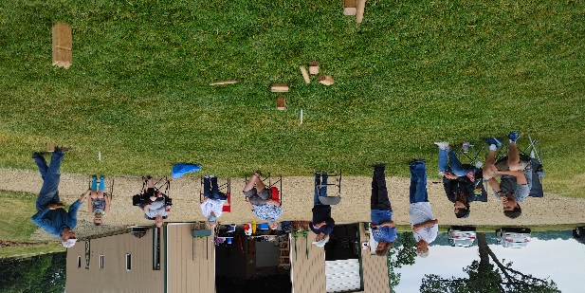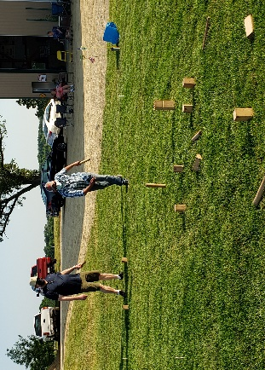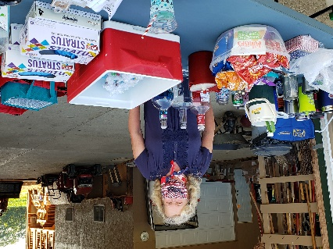
- How to play: https://youtu.be/XfWt0-_MNsY
- Rules: http://www.kubbunited.com/rules-of-kubb
- Stoughton Kubb Club: https://www.facebook.com/stoughtonkubbclub/
- Stoughton Invitational: Saturday, May 13, at Norse Park in Stoughton (new date and location). $40 team fee. Register at https://www.signupgenius.com/go/409054ca5a72c7-stoughton2?fbclid=IwAR2xr13DQsk5r0zzMdO9UucYCbAT1nExSULj_kp7X80OxT5BW96yEXGjTfU#/

