Friendly Fifth Friday News
October 14, 2022

Send all web posting info and calendar dates/events directly to our webmaster at inputd5@sonsofnorway5.com. Feel free to share this with your lodge members!
WHAT A SPOOKTACULAR HALLOWEEN!

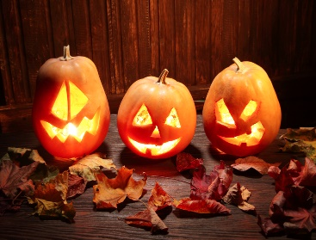

SPONSOR A JACK-O-LANTERN DECORATING CONTEST FOR YOUNGSTERS IN YOUR COMMUNITY. Ask the children to dress in costume and display their jack-o-lantern at your October meeting. Select the top three entries and acknowledge those children (or give all entrants a small treat). Some options include chocolate bars made by the Freia or Nidar companies, Swedish fish, Sour Viking delights, or Nidar Smash candies. These options are available on Amazon.com, and many are available at your local Nordic import shop.
Plan the evening snack or meal around a Halloween theme. For example, pizza, cheese bread, and festively decorated cupcakes would appeal to many. Use Hawaiian Punch®, add dry ice, and watch for the result. Fun Times! Fall is a good time of the year to serve apple cider.
Don’t ignore your veteran members. They like to dress up in costumes, too! So hold a contest for the best-dressed members! One year, our winners were a couple dressed like lefse and lutefisk!
Explore Norse mythology and the topic of the Viking Witch (Völva) or Seeress. These individuals practiced shamanism and magic. Professors from nearby universities in the Scandinavian Studies Department could be helpful resources and presenters.

LET’S CELEBRATE FALL IN OUR LODGES!

C-cHEER FOR OTHERS!
E -EXPRESS HERITAGE THRU YOUR ACTIVITIES.
L -LISTEN TO NEW IDEAS; CONSIDER WHAT COULD BE.
E -ENCOURAGE NEW LEADERSHIP.
B -BUILD RELATIONSHIPS WITH KINDNESS.
R -RECEIVE ACKNOWLEDGEMENTS JOYFULLY.
A -APPRECIATE THE HELP YOUR MEMBERS PROVIDE.
T -TREAT YOUR LODGE MEMBERS TO A SPECIAL MEAL OR ENTERTAINMENT.
E -ENERGIZE YOUR LODGE WITH NEW EXPERIENCES-DREAM.

ADULT HERITAGE WEEKEND 2022
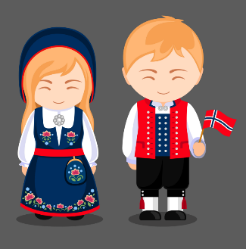

I am thrilled to share that our members had a fantastic weekend in Spring Grove, MN. Norwegian Ridge was its original name and site of the first Norwegian settlement in Minnesota. Minnesota is also the home state of the founding of the Sons of Norway. The staff at the Giants of the Earth Center coordinated the activities. In addition, its outreach coordinator, Rachel Storlie, helped to plan many different kinds of opportunities.

- Robin Fossum played Hardanger fiddle.
- Jokes and skits by our members-Ole and Lena
- Historical tours of Norwegian Ridge-Spring Grove by wagon
- Movie-Sweet Land
- Play, The First Sons of Norway Convention-the Commonweal Theater, Lanesboro, MN.
- Rebecca Hanna, Vesterheim gold medal carver, shared her collection of ale bowls.
- Diversions included the Uff-da Fest farmers and craft markets, shopping, and RockFilter Distillery
- Dr. Jonathan Storlie spoke about DNA in genealogy and public health.
- Author Elaine Hegg shared her book, Death in a One-Room Country School.
- Bill Fried shared the life of the author and the creator of the historic, Norwegian-American famed cartoon strip “Ola and Per” Peter J. Rosendahl.
- A visiting family from Norway made four varieties of amazing smørbrød sandwiches.
- Breakout sessions included Nordic stamping, making julekurver for all seasons, and producing krumkake with many twists-chocolate morsels, frosting, Gummi Bears®, and a variety of spice additives.
- Well-known musicians provided folk tunes. For example, Audry Almo provided accordion tunes during “Happy Hour.”
- Bi-lingual Pastor Rolf Svanoe led a Norwegian church service on Sunday morning.
- The Wilmington ELCA provided a lavish luncheon following the service.
- Participants toured the rare collection of artifacts at Vesterheim Norwegian American Museum, Decorah, IA, coordinated by Chivonne Marlowe under the direction of chief curator Laurann Gilbertson.

My thoughts have turned to 2023, when I hope to repeat a similar kind of weekend in a different location in our district. If you have suggestions for such an experience, please get in touch with me.

Cheryl Wille-Schlesser
200 Beth Circle
Mt. Horeb, WI 53572
608-219-4464
cwschlesser200bc@gmail.com

Foundation Month Continues!
Happy Foundation Month! As we continue to celebrate, here are some reminders of things your lodge can do to promote and highlight the Foundation and it’s resources!
- Have your Foundation Director promote scholarships and grants available. Use the pdf that gives the summary of each one (available on the website). https://www.sofn.com/wp-content/uploads/2022/09/Foundation_Scholarship_Grid_2022.pdf and https://www.sofn.com/wp-content/uploads/2020/07/Foundation_Grants-Grid_072020.pdf
- Encourage members to send in a donation using the envelope in the October Viking. Remind them to put your lodge’s name and number so your lodge gets credit!
- Have your Foundation Director give a short presentation at your meeting and have materials available.
- Pass the Piggy (or any other money collection vessel) at your meeting! Use your monthly sunshine money for the Foundation.
- Share on your social media the daily Facebook posts that I’m doing on the District 5 Facebook page.
- If you didn’t get an October activity planned, you can still do something in November or December to get into this falls campaign!
Thank you for your support!
Darlene Arneson, District 5 Foundation Director

Heritage of the Future Campaign
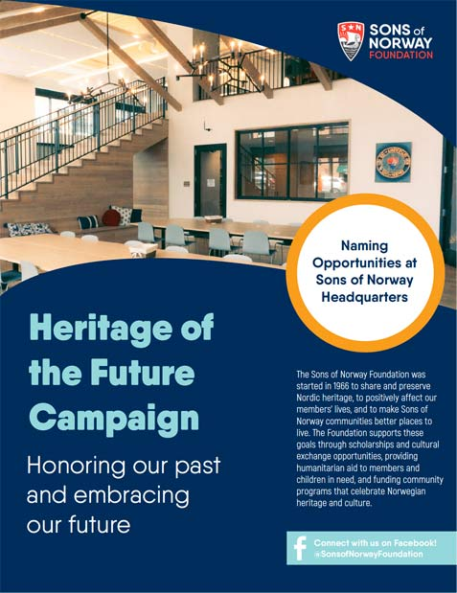
Sons of Norway is proud to announce the “Heritage of the Future” campaign to support the Sons of Norway Foundation. This naming campaign will offer the naming rights to different areas of our new home office for a wide range of donation amounts.
As the nonprofit branch of Sons of Norway, the Foundation has shared and preserved Nordic heritage since 1966. We rely on donations to maintain the scholarship and grant programs that positively affect our members’ lives and make Sons of Norway communities better places to live. Now, with the “Heritage of the Future” campaign, you can support our mission while leaving your mark on Sons of Norway’s physical building. Your philanthropic contribution will help us further our mission and inspire others to support their Sons of Norway community in the same way.
Your contributions can be designated to any existing grant or scholarship or be left in our undesignated fund to allow the foundation maximum flexibility in the future. Here are just a few examples of spaces that can be named. Contact Emily Stark at estark@sofn.com or 612-821-4655 to reserve your place now!

In 2021, the Sons of Norway Foundation distributed over $147,000 in awards.
$111,000 in Scholarships for students to study in the United States, Canada, and Norway
$23,000 In Grants for Norwegian culture and heritage programs
$13,000 In Camperships for kids across the United States to attend Norwegian cultural camps
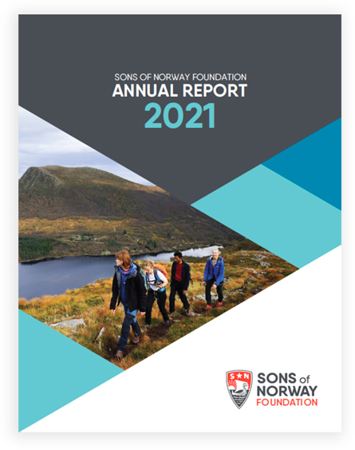

Sons of Norway Foundation Annual Report
We’re making a difference – with donations from members, lodges and friends of the Sons of Norway Foundation. Our annual reports bear witness to your generosity as well as the resounding influence of every single donation, from the stories of students who studied in Norway, to the families attending a sponsored exhibit, and so much more.
The stories, facts and donors who made it possible are right here in our archive of annual reports.
2021- https://www.sofn.com/wp-content/uploads/2022/06/2021_Foundation-Annual-Report.pdf

2022 Lutefisk Dinners (as of September 28, 2022)

Utica Lutheran Church- October 15
Mailing address: 14974 State Highway 27 Ferryville, WI 54628 608-734-3051

October 18- Myrmarken Lodge Dinner
Tuesday, October 18 6:00 PM Eagles Club 1104 S. Oak St. Marshfield $16.00 call 715-305-9699 or 715-207-0550 for reservations. Lutefisk, meatballs, lefse, potatoes, rutabagas, salad, & great desserts!

October 22: Orfordville Lutheran Church, Orfordville, WI
https://orfordvillelutheran.org/OLC/events/norwegian-dinner/

NBC Lutheran Church- October 23
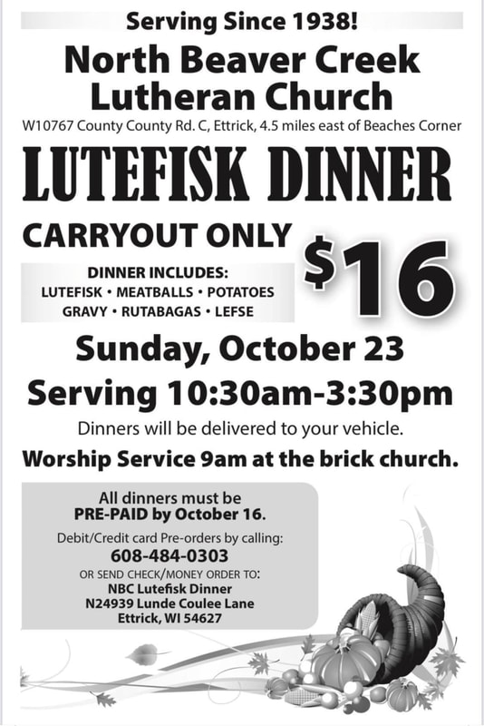

Our Savior’s Lutheran- October 27, Beldonville, WI
Our Savior’s 74th Annual Lutefisk Supper
Thursday, October 27, 2022
Serving 2:30 – 6:00 p.m.

Limited Tickets – Order Early – Reservations Required
Dine-In time reservations required.
www.oursaviorschurch.info
715 273 4570
Email: admin.os@hbci.com

Our Savior’s Lutheran Church
N6450 530th Street
Beldenville, WI 54003
Lyster Lutheran Church- Saturday, November 5- W1771 Co Rd D, Nelson, WI 54756
Sons of Norway Norse Valley – November 5, Oshkosh, WI

Christ Lutheran Church- DeForest, WI – November 12

LUTEFISK DINNER RESERVATIONS -2022
https://www.christlutherandeforest.org/outreach/lutefisk/
It’s time to think about Lutefisk 2022!
Fall is in the air…a sure sign that it’s time for the annual Lutefisk and Meatball Dinner at Christ Lutheran Church! We expect about 1,200 members, friends and neighbors to come to enjoy this wonderful meal, which includes the area’s best-tasting lutefisk, homemade meatballs, the best potato lefse around, as well as rutabagas, mashed potatoes and gravy, coleslaw, cranberries and delicious pies.
Date: Saturday, November 12, 2022
Time: Seatings begin at 11:00am, and continue every hour until 5:00pm
Cost:
Adults = $23.00
Children (Ages 4-12 yrs) = $11.00
Children (0-3 yrs) = Free
Reservations: can be made beginning Wednesday, September 7, 2022 through Tuesday, November 8, 2022 at NOON. There are 2 ways to make a reservation:
Online – Use the Sign Up Genius – Lutefisk Reservation link shown below
Sign Up Genius – Lutefisk Reservations
Call the Church Office at (608) 846-4718

Payment: Those making reservations must pay for their spots ahead of time. Payments must be received by November 9, 2022. There are 3 ways to submit payments:
Mail: Checks and cash can be mailed to the church at 220 S Main St, DeForest WI 53532
Office: Checks and cash can be dropped off in the office or in the outside box located by the office door – 220 S Main, DeForest WI 53532
Online: When making your reservations online, there is also an option to pay for your reservations right in the same spot. One-stop shopping! There is a small convenience fee when paying online
Walk-ins and carry out meals are also welcome!

Another update:
The Town of Norway Lutheran Church traditionally has a dinner in early Feb. They cancelled for covid, but I think have it next year. Barbara

Deadlines and Dates! Changes in red!
- October 28-29- District 5 Board Meeting- Eau Claire, WI
- November 10- Photo submissions for the Viking to LaVonne Wier at 2nor1rus@gmail.com
- December 10- Photo submissions for the Viking to LaVonne Wier at 2nor1rus@gmail.com
- January 10- Photo submissions for the Viking to LaVonne Wier at 2nor1rus@gmail.com
- February 10- Photo submissions for the Viking to LaVonne Wier at 2nor1rus@gmail.com
- March 10- Photo submissions for the Viking to LaVonne Wier at 2nor1rus@gmail.com
- April 10- Photo submissions for the Viking to LaVonne Wier at 2nor1rus@gmail.com
- May 10- Photo submissions for the Viking to LaVonne Wier at 2nor1rus@gmail.com
- June 10- Photo submissions for the Viking to LaVonne Wier at 2nor1rus@gmail.com
- July 10- Photo submissions for the Viking to LaVonne Wier at 2nor1rus@gmail.com
---------------------------------------------------------------------------------------------------------
Viking Chest / Immigrant Trunk Schedule
Apr 2022 to Oct 2022:
Chest--zone 5
Trunk--zone 6
Oct 2022 to Apr 2023:
Chest--zone 1
Trunk--zone 2
Apr 2023 to Oct 2023:
Chest--zone 4
Trunk--zone 3
Oct 2023 to Apr 2024:
Chest--zone 6
Trunk--zone 5

Apr 2024 to Oct 2024
Chest--zone 2
Trunk--zone 1

Oct 2024 to April 2025
Chest--zone 3
Trunk--zone 4

Note:
- Check correspondence from the International and District and the International (www.sofn.com) and District (www.sonsofnorway5.com) websites for any updates and changes.
- Additional deadlines for the District 5 and International Conventions/Lodge Meetings will be added as those dates are established. Watch for future mailings and the District 5 website.

Compiled by Darlene Arneson, SN District 5 Secretary (arnesonfamily5@gmail.com or 608-873-7209)
-----------------------------------------------------------
FFFN Basics
In an attempt to help our lodge leaders become more familiar with resources, changes, deadlines and other information, I will compile a weekly “Friendly Fifth Friday News” email to our leadership. Some of the information you might already have, but hopefully it will be a good reminder for all of us (me included) of all the great resources that Sons of Norway has to offer. Please feel free to cut and paste any of this information for your lodge’s use!

Send all web posting info and calendar dates/events directly to our webmaster at inputd5@sonsofnorway5.com With our new arrangement, I actually send the FFFN pdf to our webmaster on Thursday morning before I go to work. So if you have anything you’d like me to consider putting in, please send it by 4 am on Thursday morning. Please do not send pdf’s as I have a hard time cutting and pasting them. The Word Document works best for me. Don’t forget that lodge events should be submitted to inputd5@sonsofnorway.com as I have a hard time keeping track of all lodge activities. I’ll put some in but that is more the role of the website event calendar.

If you would like to get the MS Word document, just shoot me an email and I’ll add you to the list. I send it out right after I send the email to the large group.

Darlene Arneson – arnesonfamily5@gmail.com

