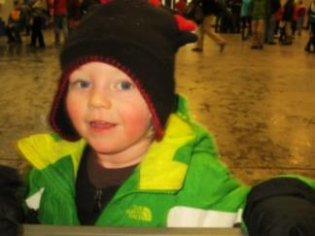 2019 Barnebirkie Volunteer Sign-Up
Thursday, February 21, 2019

Name: _______________________________________________________
Lodge: _______________________________________________________
Address: _____________________________________________________
Telephone: (___)_____________________Cell: (___)_________________
e-mail address: ________________________________________________

Possible Areas of Assistance:
____ Registration (Thursday 2-21-19, 9 AM to 12:00 Noon) Computer Work, Hand out race bibs and hats to preregistered and newly registered barne skiers
____Race Start (Behind Hayward Primary and Intermediate Buildings (11:30 AM)
____Become a Costumed Character and greet families and barne skiers (11:15 AM
____Greet families and distribute treats at the Cookie Tent in downtown Hayward
____Help register other youth skiers: junior birkie, barkie birkie, adaptive ski
____Assist wherever the American Birkebeiner Ski Foundation needs help
____Greet families and distribute cookies at the Expo, Hayward High School
____Make a donation

- Most events are outside, dress warmly!

I would like to help at the Sons of Norway cookie table at Hayward High School. The cookie table is coordinated by Mary Bennett and Asta Blanchar of Idun Lodge in Madison.

____Thursday AM ____Thursday PM ____Thursday Eve
____Friday AM ____Friday PM ____Friday Eve

A volunteer reception will be held immediately after the Barnebirkie at the
Veteran’s Community Center located at the corner of Highway 63 and Main Street.
*We request that only cookies without nuts are donated.

*Monetary contributions in check form should be made out to “Sons of Norway – Fifth District” and identified in the check memo area as “For Barnebirkie”.

Send to: Cheryl Wille-Schlesser, District 5 Sports and Rec. Director, 200 Beth Circle, Mt. Horeb, WI 53572 Questions? Call: 608-219-4464, e-mail: rogrcher@mhtc.net

PLEASE NOTE THAT RACE STARTS ARE SUBJECT TO CHANGE AND CONDITIONS.

